* **Lab Task 6**

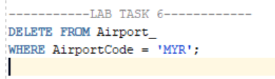Delete you as an employee

OUTPUT: